**CSCI201 Common Problems Guide**

**Your first step in solving any issue should be searching the problem as precisely as possible online. The following are select issues that students often encounter.**

*If you have any suggestions for additions to this document, or run into any environment-related issues that may be applicable to other students in the class, please e-mail* [*hgil@usc.edu*](mailto:hgil@usc.edu)

* “Some projects cannot be imported because they already exist in the workspace”

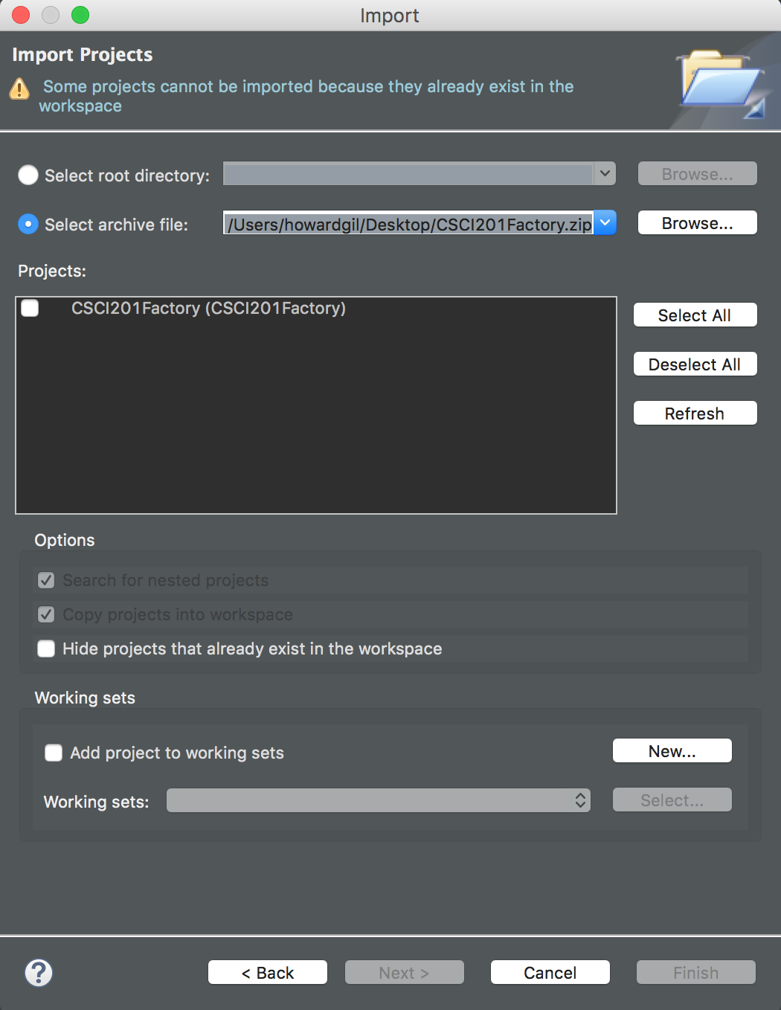

You are trying to import a project with the same name as an existing project. You cannot have two projects with the same name, because then they would have the same path.

Rename the project you want to import or rename your old project:

Right-click project > Refactor > Rename

(If Refactor is not available, try Right-click project > Rename)

* “Run On Server” not shown as option

Before trying “Run As…” double-click the HTML file you want to run (e.g. index.html)

* HTTP Status 404 when running on server

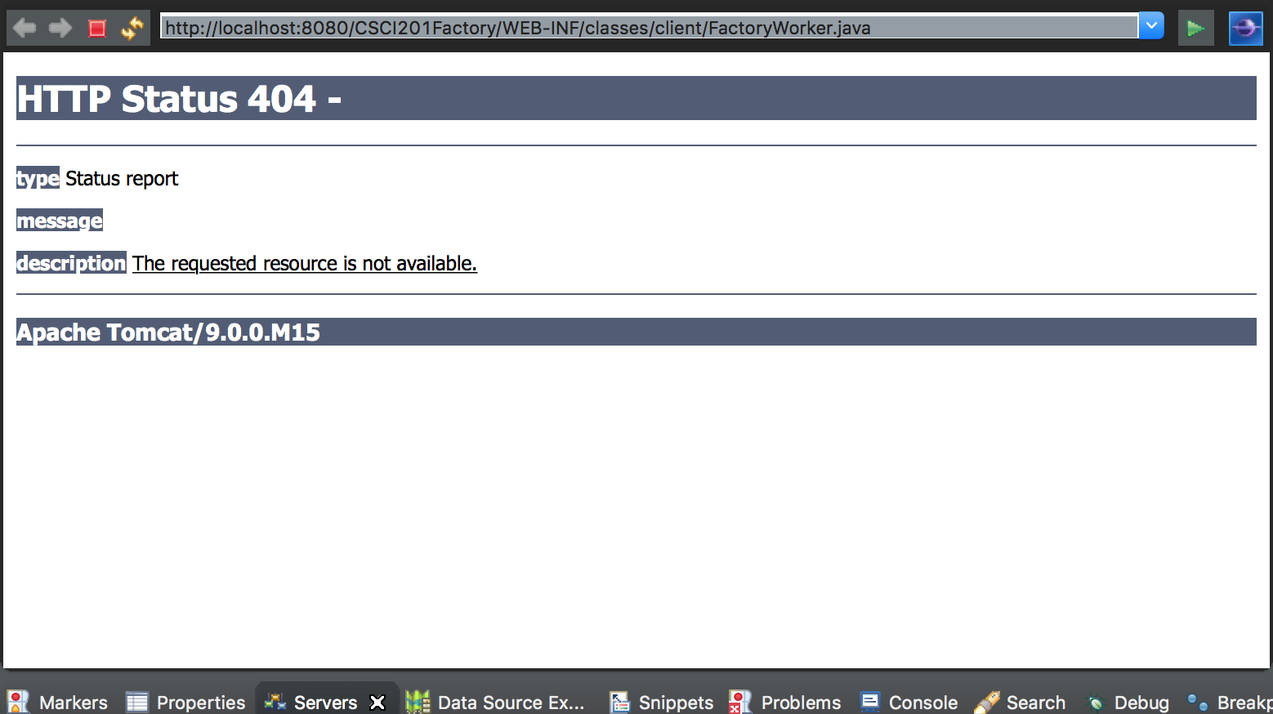

If you know your server is configured correctly and the file exists, you may be trying to run a non-web file. You should only use “Run on Server” on the HTML file. Before trying “Run As…” double-click the HTML file you want to run (e.g. index.html).

* This site can’t be reached

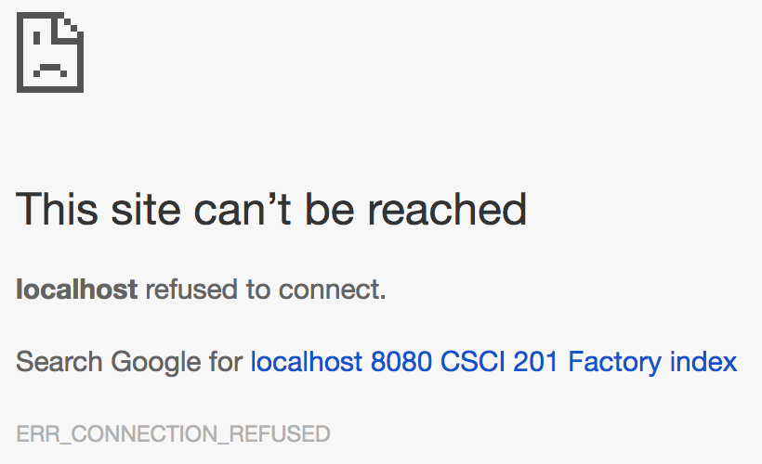

Make sure your server is running.

Check for any interfering firewalls.

* Project not building or taking forever

If you have a red “x” on project but no errors in any files, this is likely a build path error.

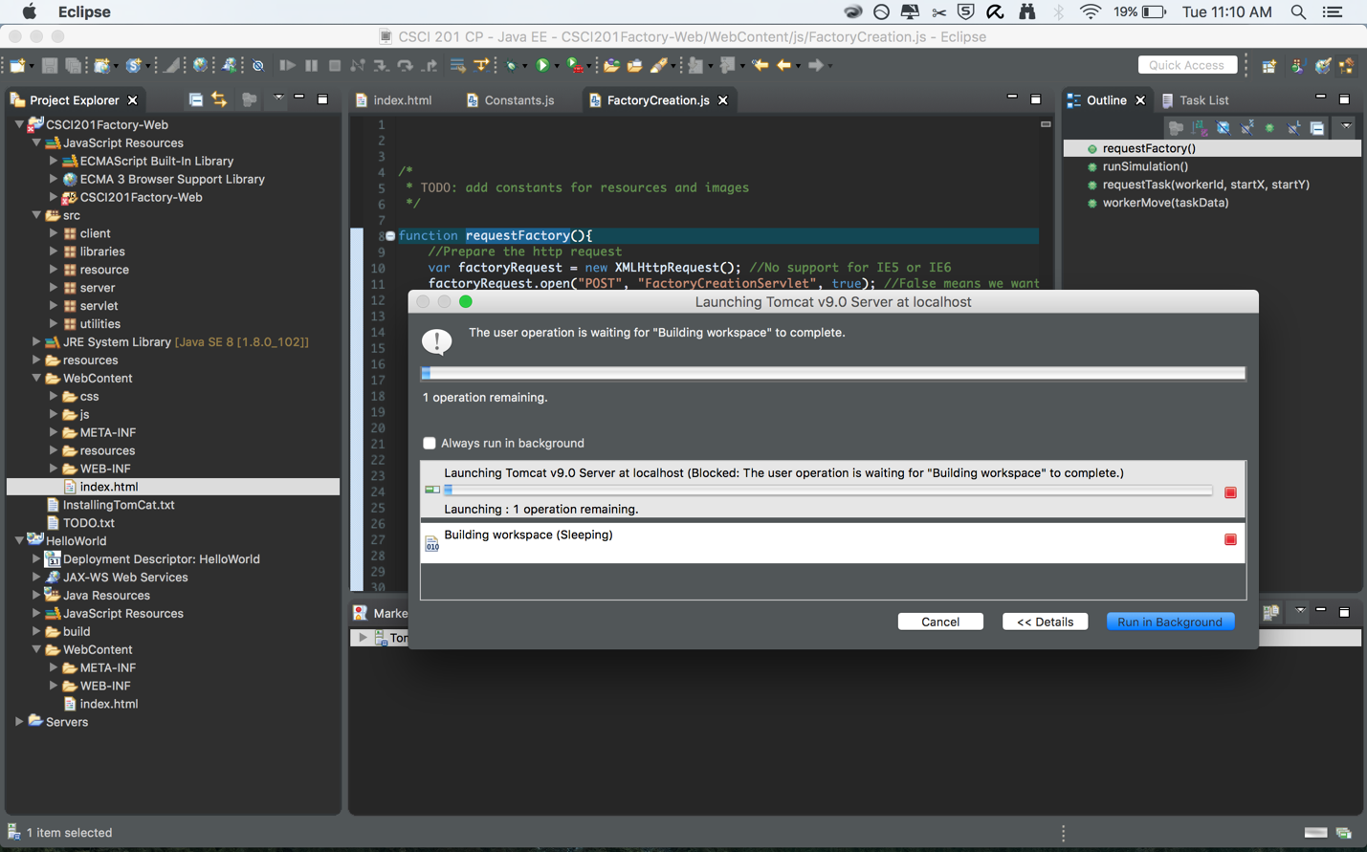

Right-click project > Properties > Java Build Path > Libraries

* + If gson-2.3.1.jar has errors:
    1. Select it > Edit…
    2. Navigate to your project folder and search for gson-2.3.1.jar
  + If JRE System Library has errors:
    1. Select it > Edit…
    2. Select Workspace default JRE > Finish

Be sure to “Apply” the changes before pressing “OK”

* “’Publishing to Tomcat v9.0 at localhost…’ has encountered a problem.”

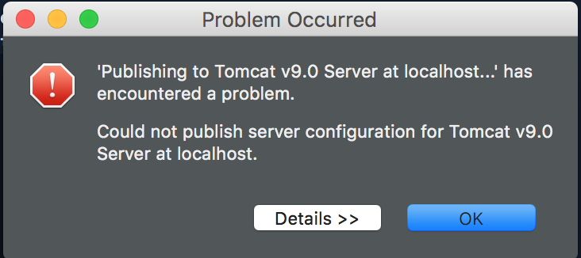

Delete your Tomcat server (Right-click server > Delete)

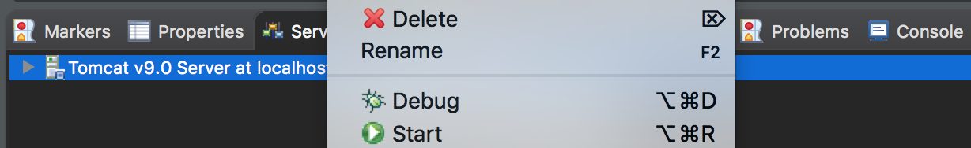

Re-add the Tomcat server (click the blue text that appears in its place)

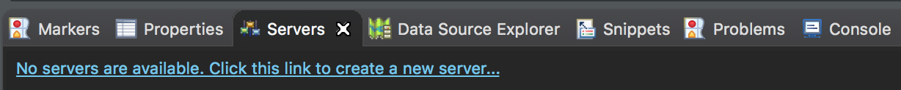

Select Apache Tomcat v9.0 > Finish

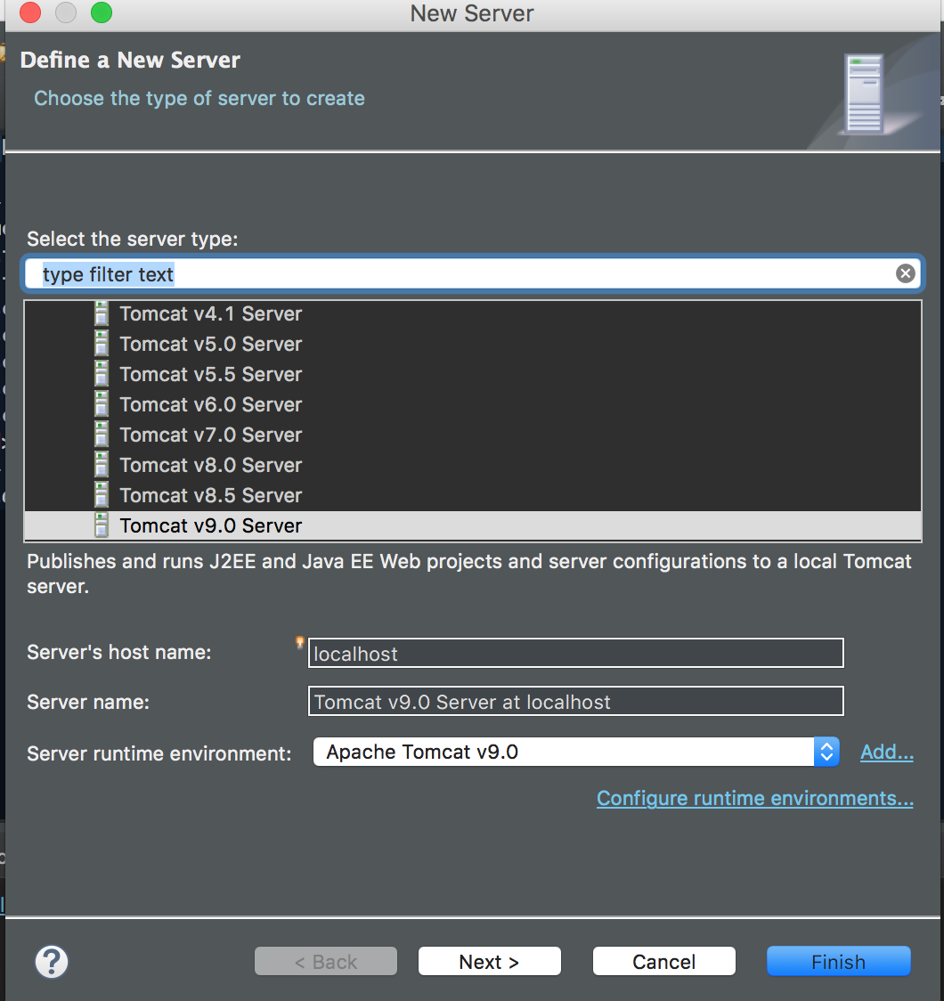

* "…port already in use"

**Windows:** Open up Task Manager -> Services and end Tomcat

**Mac:** Save your work and restart your computer (if you find an alternative method please let us know)

* **Catch-all**

Save your work and safely restart Eclipse. Else, restart your computer.